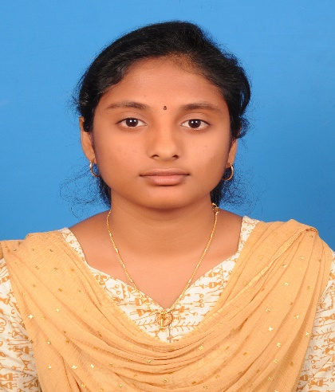

1

© Capgemini 2017. All rights reserved

|



**Strengths**

**Achievement**

**Education**

**Base Location:**

**Email ID:**

**Mobile No:**

**Grade:**



**Online Movie Ticket Booking Application**

Completed end to end case study on Online Movie Ticket booking using Spring boot and React Js. It is a double-role application Project i.e. Admin and User where admin adds the movie and theatre details. User can register and login to book and view the movie . Admin also manages the screen, seat details and also delete the customer details.

.

Analyst/Software Engineer

**Chennai**

varshini.dinakaran@capgemini.com

+91

8525021721

•

A self driven learner with Front

-

End and Back

-

End

knowledge. Passionate about implementing and

launching new projects.

•

Ready to learn new technologies/Frameworks and

implement them to further improve my knowledge.

•

A team player with good communication skill always

ready to work for the enrichment of knowledge.

•

Has working knowledge on React Js ,Java and Spring Boot

Microservice Development using Spring framework on

an Begginer level.

 https://github.com/vdinakaran/Project.git

Bachelor of Technology

CSE – 2017-2021

**Skills**

Spring Boot

Spring MVC

JPA CRUD

React Js

AWS

**Backend**

Java

Spring

Spring Boot

REST API

**Database**

SQL database

–

Postgres

**Web Technologies**

HTML5

CSS3

Javascript

React

**AddOns**

Github

Maven

Postman

**Additional Details**

Excellent Communication Skills

Team Player

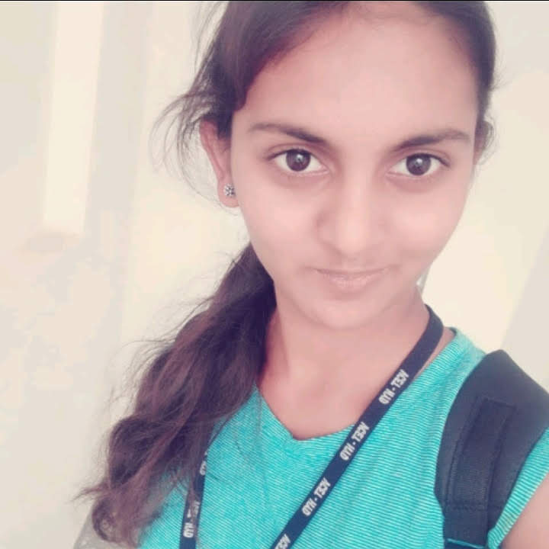

**Varshini Dinakaran**

A4